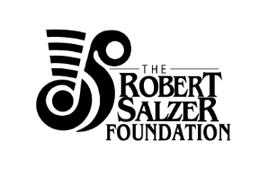

Grant Application Form Preview

Please note, this is a preview form only. Applications will only be accepted online
- Organisation Details
- Name of organisation:
- ABN:
- Charity Status:
- Contact Name:
- Contact Email Address:
- Contact Number:
- Address:
- Website:
- About your organisation: Please provide a brief overview, including mission of your organisation. (100 words)
- Please list your organisation’s Board Members:

- Project Details:
- Name of Project:
- Project Dates: Please list the dates your project will take place, please identify if these dates are confirmed or proposed.
- Project Location: Please note where this project is intended to take place
- Type of Project:
1. Opera performance, creation or career development
2. Other musical performance, creation or career development
3. Other theatrical arts performance, creation or career development
4. Visual arts
5. Literary arts
6. Other

- Project Directors, who will be overseeing the project? Please list names along with a short bio: (300 words)
- Project Description: (150 words)
- Project Objective: (100 words)
- Artists/Creative Team Profile: Please list the principal artists for this performance with a short bio (up to 500 words).
- Who are the intended audience, how many people do you intend to reach and what is their demographic? (100 words)

- Funding Request:
- What is the $ amount you are seeking to request from the Robert Salzer Foundation? If this is a multi- year request, please provide details. Please note however, multi-year requests are generally not favoured.
- Total cost of production/program:
- Other proposed sources of funds (including amounts): (Indicate whether confirmed or only applied for or contemplated.)
- Does your organisation receive federal or state government funding? If so, please state the percentage amount relative to your overall costs.
- What specifically will the funding requested be used for: (100 words)
- Have you previously received funding support from the Robert Salzer Foundation? If so please list the amount and year of funding.
- Budget: please upload a copy of the budget that relates to this application: (budget template can be downloaded

- Additional Information:
- We agree to provide a project report and acquittal for this grant.
- Please include any additional information you wish to share about this project (up to 250 words).
- Attachments: Please upload any other supporting documentation you wish to include, such as images, calendar of events, press or letters of support.

- Submit

